**BRAC University**

**Department of Computer Science and Engineering**

**CSE 110/162**

**Lab 2**

**Objective**

In today’s lab, we will look at the basic building blocks of all computer programs – variables and literals. We will see the different data types available in java, and how to create variables and literals for each data type. We will conclude by writing a few simple programs using the java programming language.

**Problem Statement**

Let us begin by getting students familiar with the software we will be using to write and test our programs.

**Open Dr. Java:**

**On the Desktop**, you should see an icon for DrJava (it looks like a big "J", ).



Double click on it. The main window of DrJava is broken up into three panes.

On the left side, you should see a narrow pane containing the word "(Untitled)." This is shown in the screenshot below, circled in red.

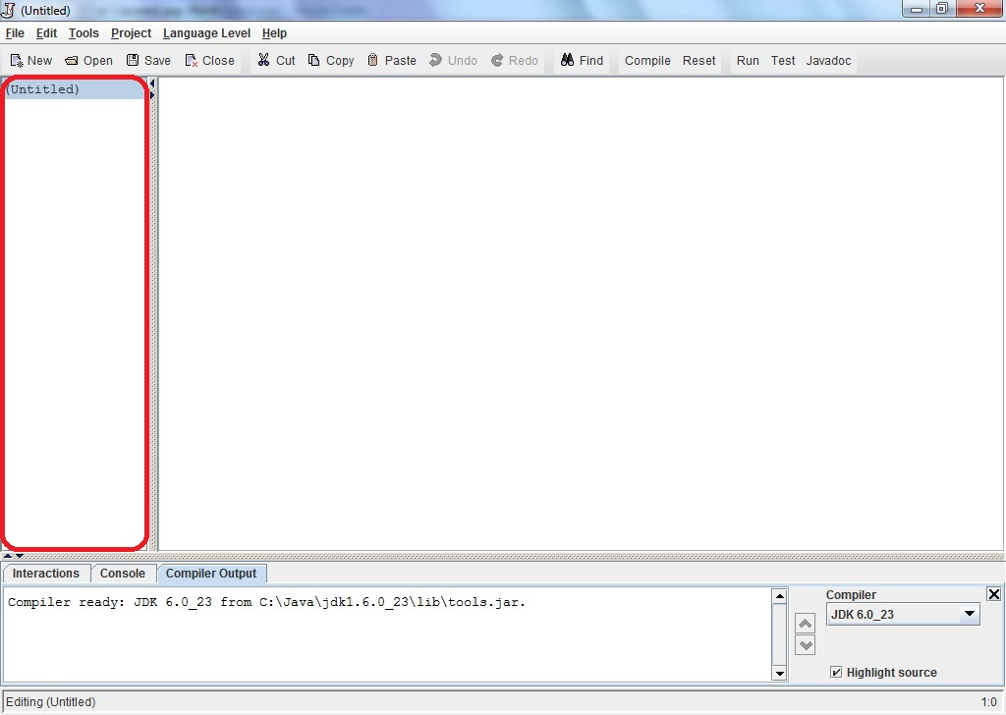

The large pane to the right of that is where you should type your program. At the bottom of the window is a pane with three tabs "Interactions", "Console", and "Compiler Output." These are shown in the image below, circled in red, black and blue respectively. Please check with the image and make sure you see these tabs on your Dr. Java window.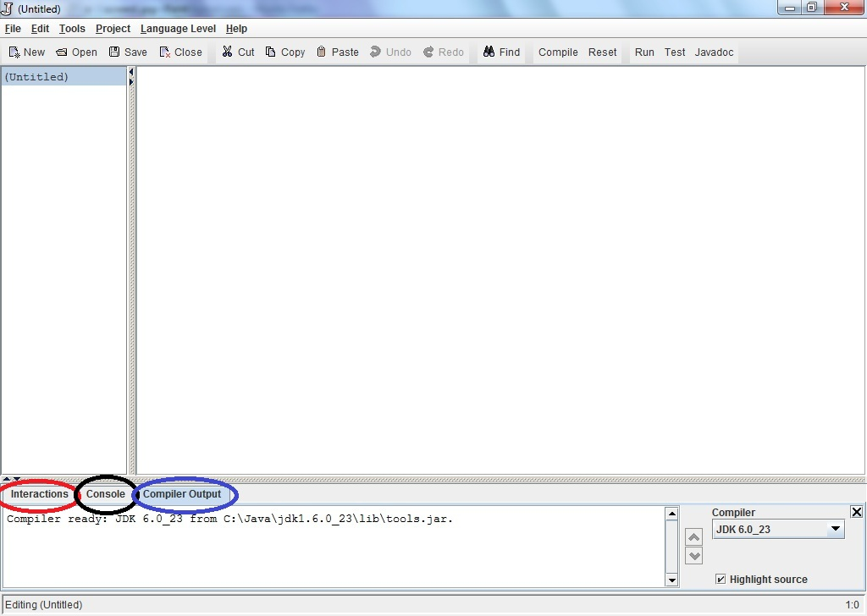

**Write Java statements in the Interactions pane: [21]**

Click on the "Interactions" tab in the bottom pane. This is a great feature of Dr. Java.

Here, you can type any Java expression and Dr Java will instantaneously compile, interpret, and evaluate it. Try it by typing the following Java expressions. Type them in exactly as shown, including the quotation marks. Record the result of these interactions.

1. 3
2. 3+5
3. 4/6
4. 4.0/6
5. 4/6.0
6. 4.0/6.0
7. 9 - 4 * 3
8. (9 - 4) * 3
9. 3 /4 * 2
10. "hello" + "goodbye"
11. "3" + "5"
12. "3 + 5 is " + 3 + 5
13. "3 + 5 is " + (3 + 5)
14. 3 + 5 + “ is 3 + 5”
15. (3 + 5) + “ is same as 3 + 5”
16. Math.pow(2,3)
17. Math.pow(15, 0.5)
18. Math.sqrt(16) + 8.3
19. Math.pow(2,3) + Math.sqrt(64)
20. Math.pow(Math.pow(2,3),2)
21. Math.toRadians(3)
22. Math.sin(90)
23. Now, based on your current knowledge, experiment and find out how to calculate the value of sin 90 degree. Your answer should be 1.0 or very close. Hint: Combine u & v.

You may be discouraged by Java's poor math skills in examples l and m. In fact, the "+" operator does different things depending on its arguments. If both arguments are numbers, it adds them; if either argument is a String of characters, it concatenates them into a single String. **We will talk more about this in lecture later**. In the Interactions pane, you can also type more complex Java statements. For instance, to write "Hello World" to the console, we can use the println method. Type the following in the **Interactions** pane:

System.out.println("Hello World");

Now print your name to the console. Click on the **Console** tab and you should see:

Hello World

For most of the programs that you write in this class, the output of your program will be a series of statements printed to the console.

Try to print your name following the previous method.

**Write your first program:**

***[ Note to Instructor:* Please discuss/explain flowcharts and construct the flowchart for the “Hello World” program before discussing the code. ]**

Your first program will be a simple one: it prints "Hello World!" to the console.

Create a class called **HelloWorld** with **System.out.println("Hello World!");** As an example, here is a class called **HelloBRACU** which prints **"Hello BRAC University!"** to the console. The class has one method called main. Inside the body of main, there is a single statement, a call to the println method of the System.out object (We will discuss about classes and objects more in class lectures).

**Tasks:**

1. Change the name of this class to **HelloWorld**
2. and also **change what it prints** to the screen.
3. Also, **change the author** listed in the comment at the top of the program.

**// My first program**

**// Author: Matin Abdullah**

**public class HelloBRACU**

**{**

**public static void main(String[] args)**

**{**

**System.out.println("Hello BRAC University!");**

**}**

**}**

Save your program to a file on the **Desktop** with the filename

**HelloWorld**.java

**Note: Java requires the file name to match the name of the class defined in the file**.

Click the “**Compile**” button (or under the Tools menu, select "**Compile All Documents**"). Once DrJava has compiled your document, you should see the message Last compilation completed successfully. in the "Compiler Output" tab of the bottom window pane. Now if you look on the Desktop, you should see another file called **HelloWorld.class**

This file contains the bytecode into which your program was compiled. When you run your program, it is this bytecode that is interpreted by the Java virtual machine.

Now it is time to run your program. Go to **Tools->Run Document's Main Method**. Again in the bottom pane under the Interactions tab you should see:

Welcome to DrJava.

> java HelloWorld

Hello World!

Under the Console tab, you should see only: "Hello World!" Congratulations, you wrote your first of many programs in Java! Notice that double quotes (“”) are not visible in the output.